Name of activity | Industrial visit to Prashant corner
Objectives of the activity  (maximum 40 words) | • To guide students about career opportunities after graduation.  • To help students understand how industries work.  • To help students understand the challenges faced by employees and motivation to work
Organizing department/s | Department of Human Science
Collaborative institute | Nil
Date (DD / MM / YYYY ) | 18/09/2025
Venue | Prashant Corner
Mode (Online/Offline/ Hybrid) | Offline
Details of Resource Person/ Speaker  (name, designation, institute) | Prashant Corner
Key Participants | Students of Department of Human Science
Remarkable outcomes / key take away messages (max. three) | - • Students gained awareness about the functioning of industries  - • Students understood how sweets are made and processed  - • students explored the challenges faced by the workers and employees of the industry
Details of Teachers participants | M 0 F 2 T =2
Details of Student participants | M 2 F 22 T =24
Outsiders | NIL
In-house | Students of Human Science
Additional information
Name of Co-ordinator | Nupur L. Talele
Geotagged photo | 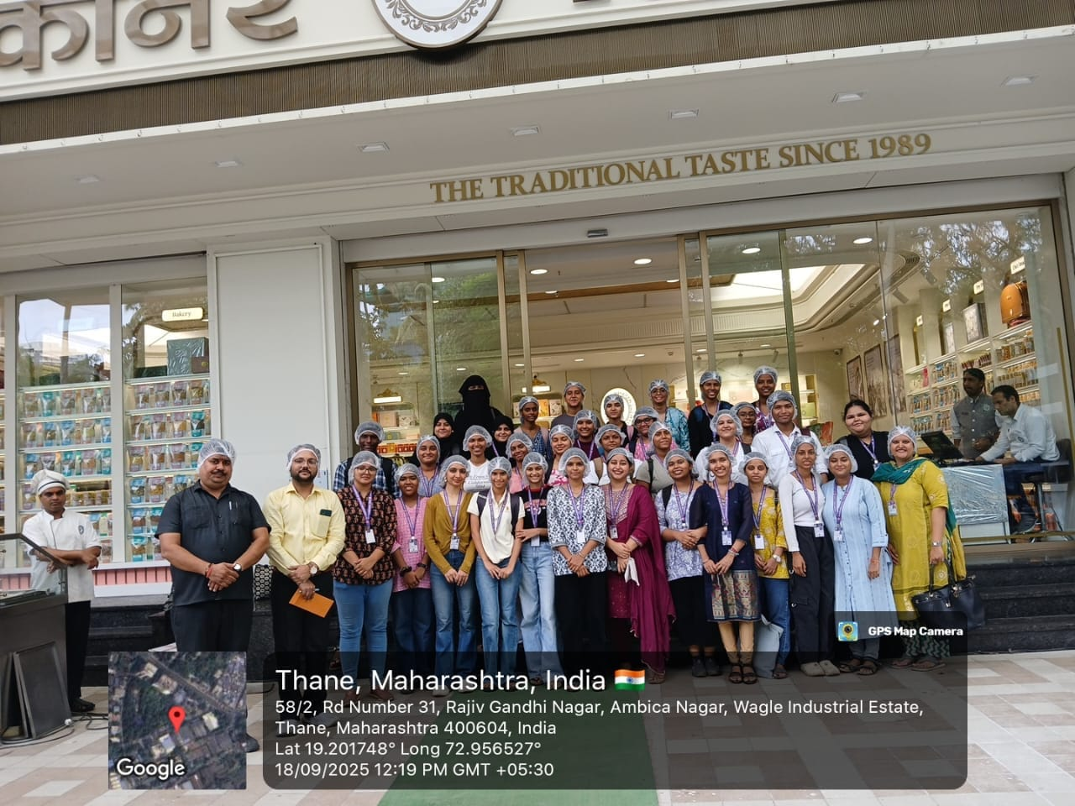  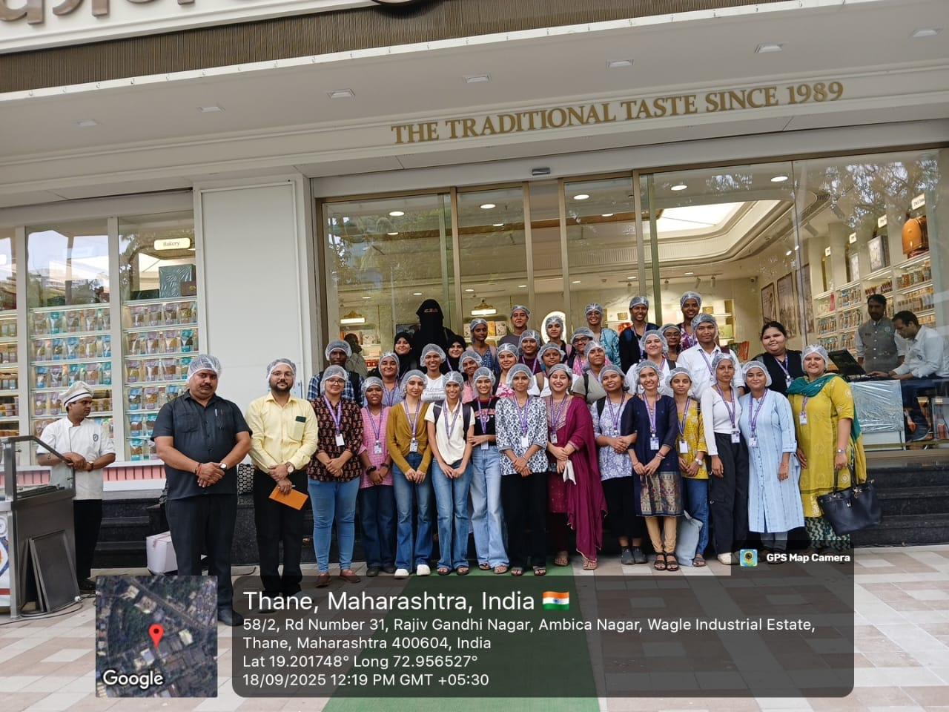
Flyer/ Notice | 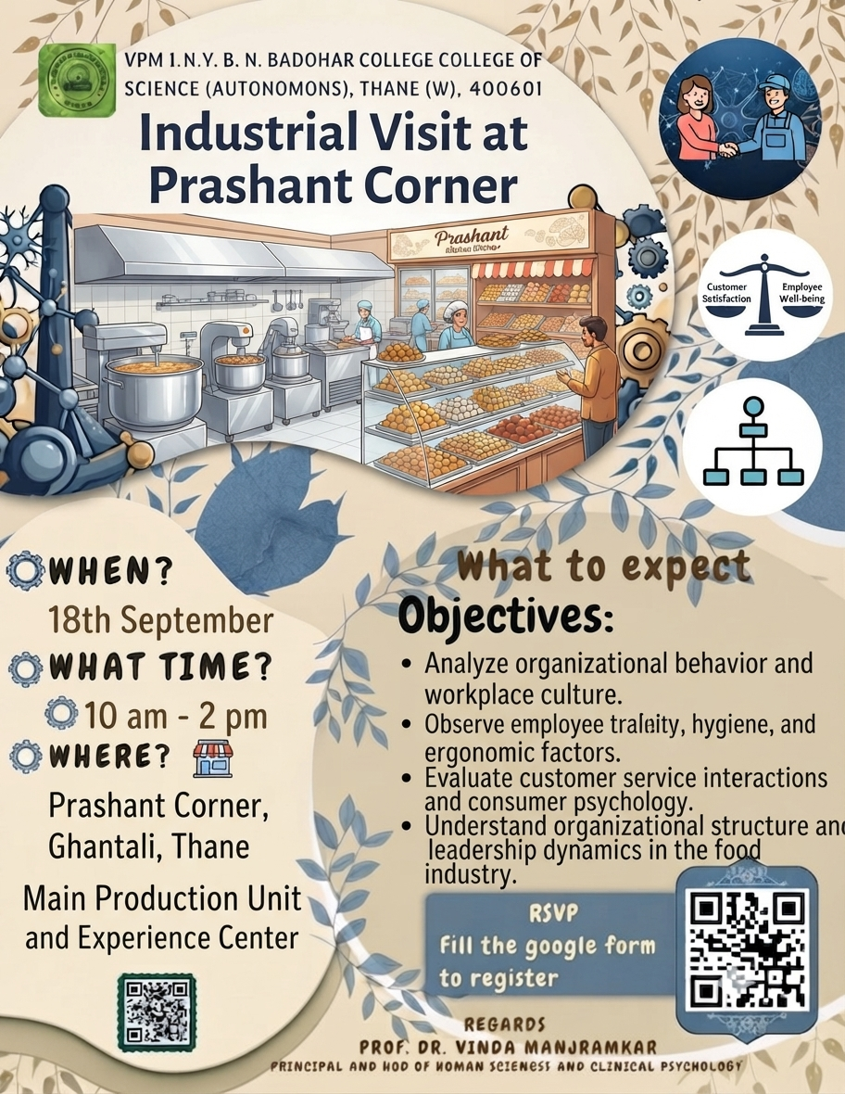
Attendance | 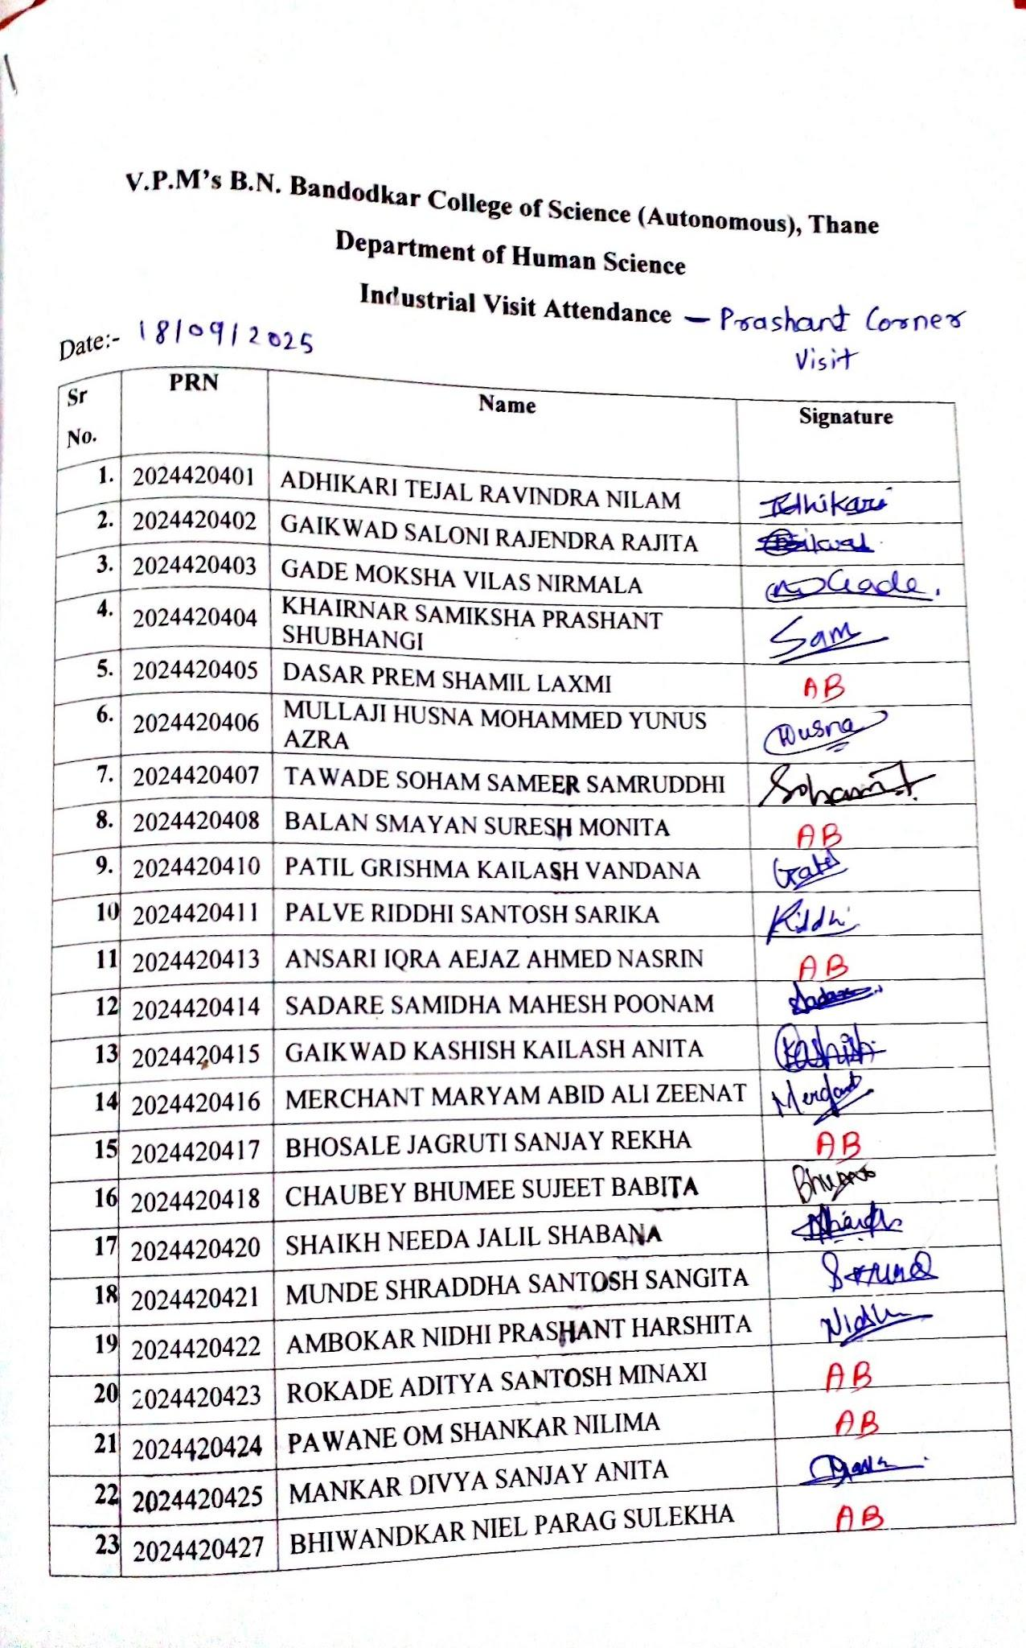  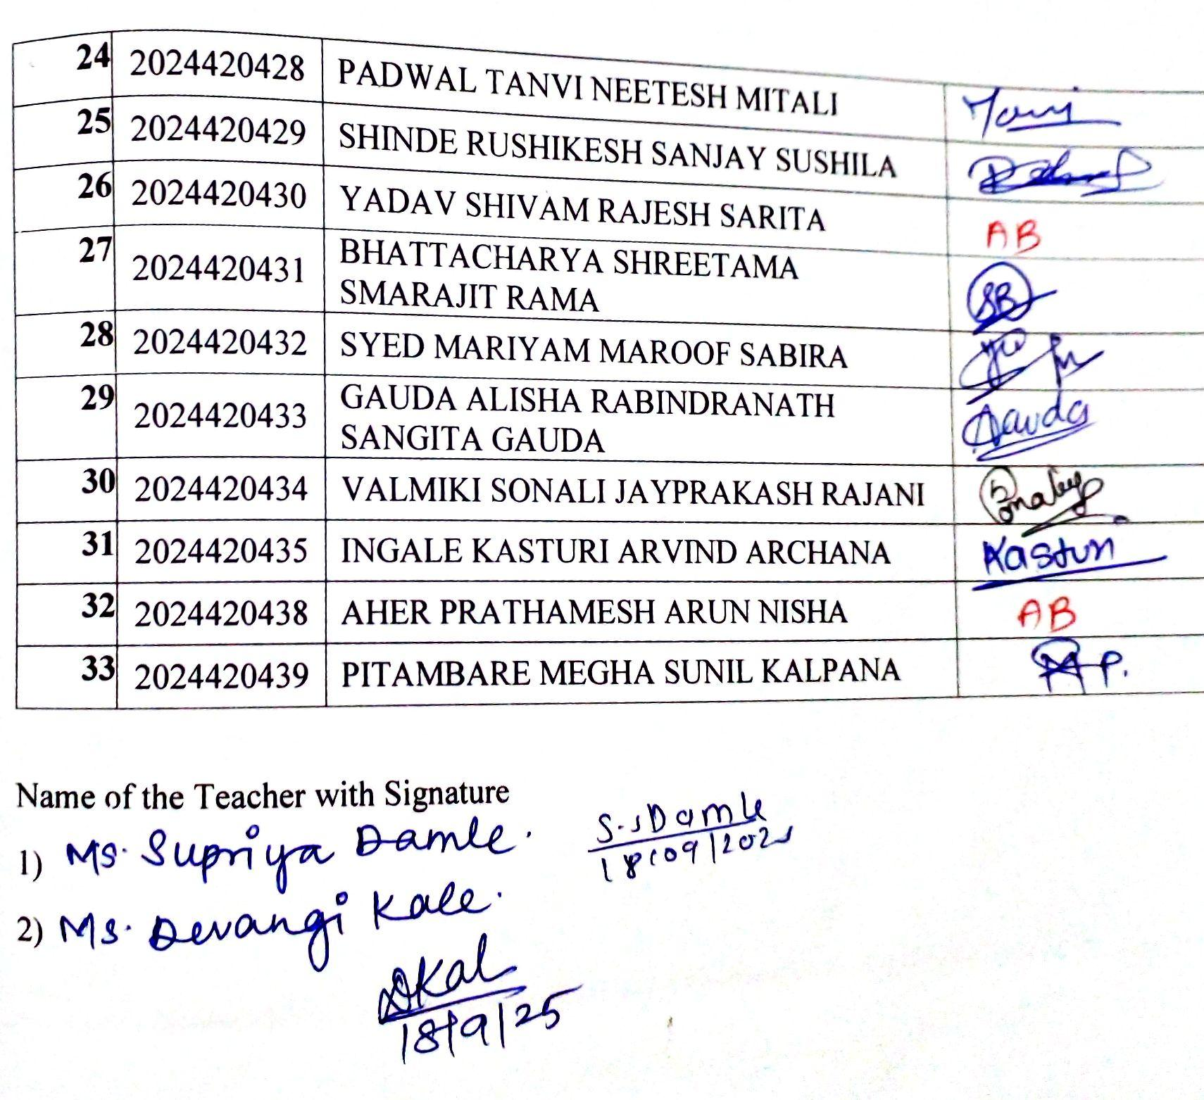
Feedback analysis | 

