Name of activity | Industrial visit to Kalwa Carshed
Objectives of the activity  (maximum 40 words) | • To guide students about the industrial management at kalwa Carshed  • To help students understand how industries work.  • To help students understand the challenges faced by employees and motivation to work
Organizing department/s | Department of Human Science
Collaborative institute | Nil
Date (DD / MM / YYYY ) | 20/09/2025
Venue | Kalwa Carshed Central Railway
Mode (Online/Offline/ Hybrid) | Offline
Details of Resource Person/ Speaker  (name, designation, institute) | Kalwa Carshed Central Railway
Key Participants | Students of Department of Human Science
Remarkable outcomes / key take away messages (max. three) | - • Students gained awareness about the functioning of Carshed Industries  - • Students understood how Industries work  - • students explored the challenges faced by the workers and employees of the industry
Details of Teachers participants | M 1 F 0 T =1
Details of Student participants | M 2 F 09 T =11
Outsiders | NIL
In-house | Students of Human Science
Additional information
Name of Co-ordinator | Nupur L. Talele
Geotagged photo | 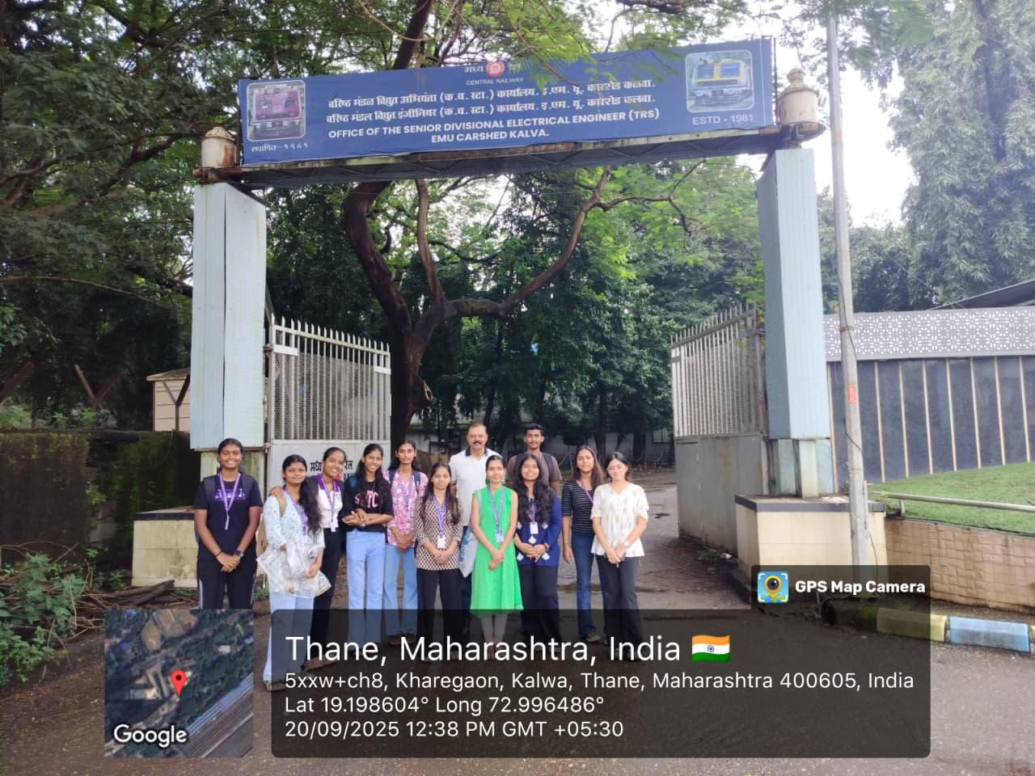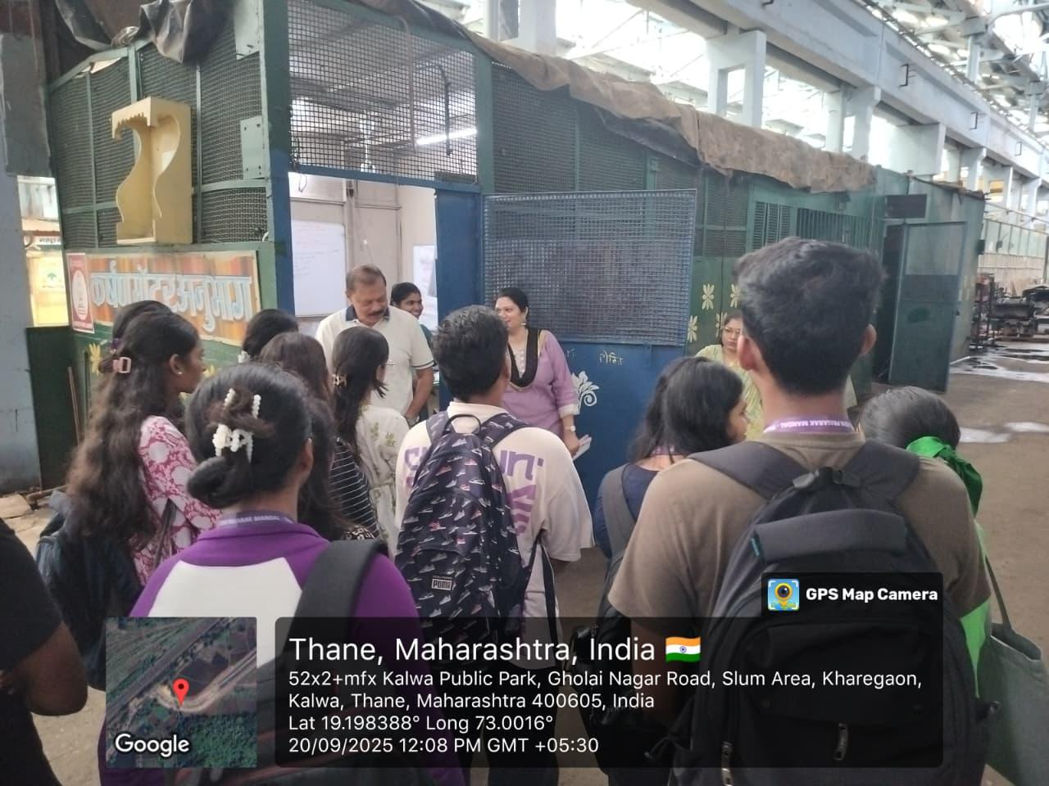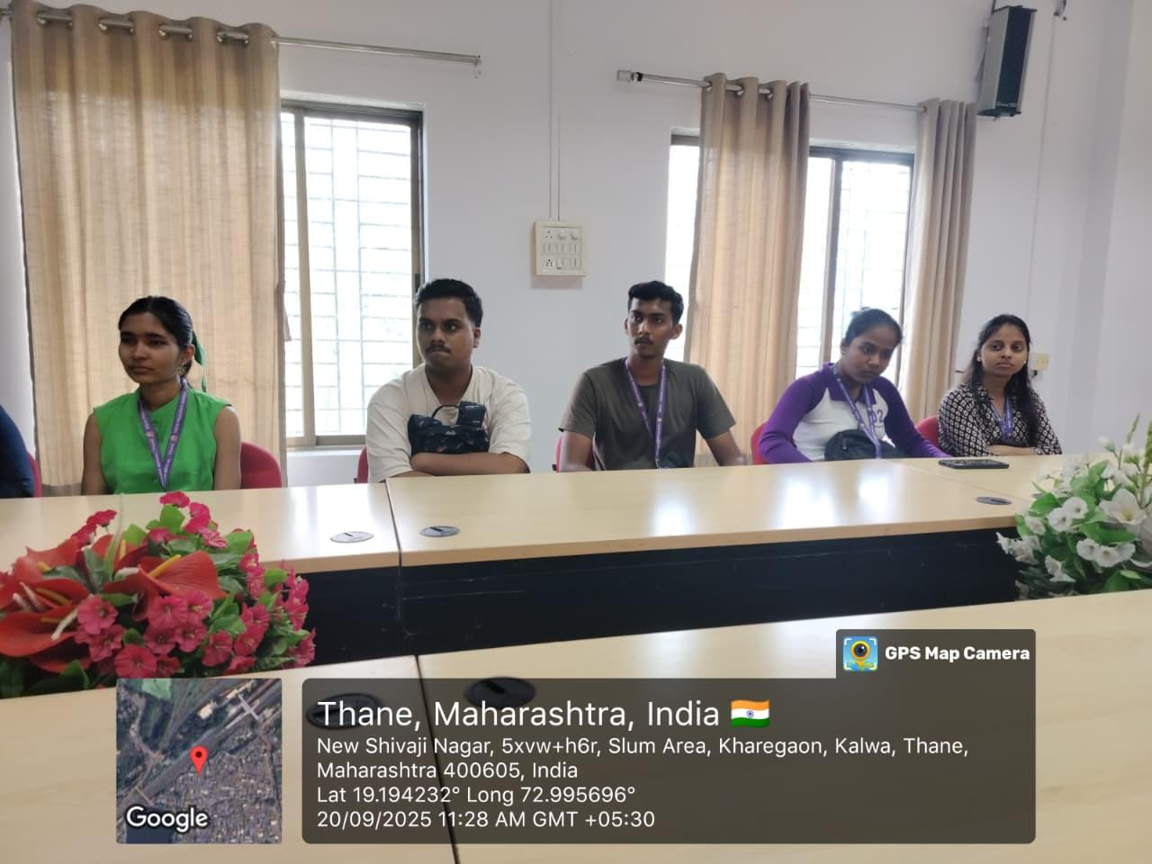
Flyer/ Notice | 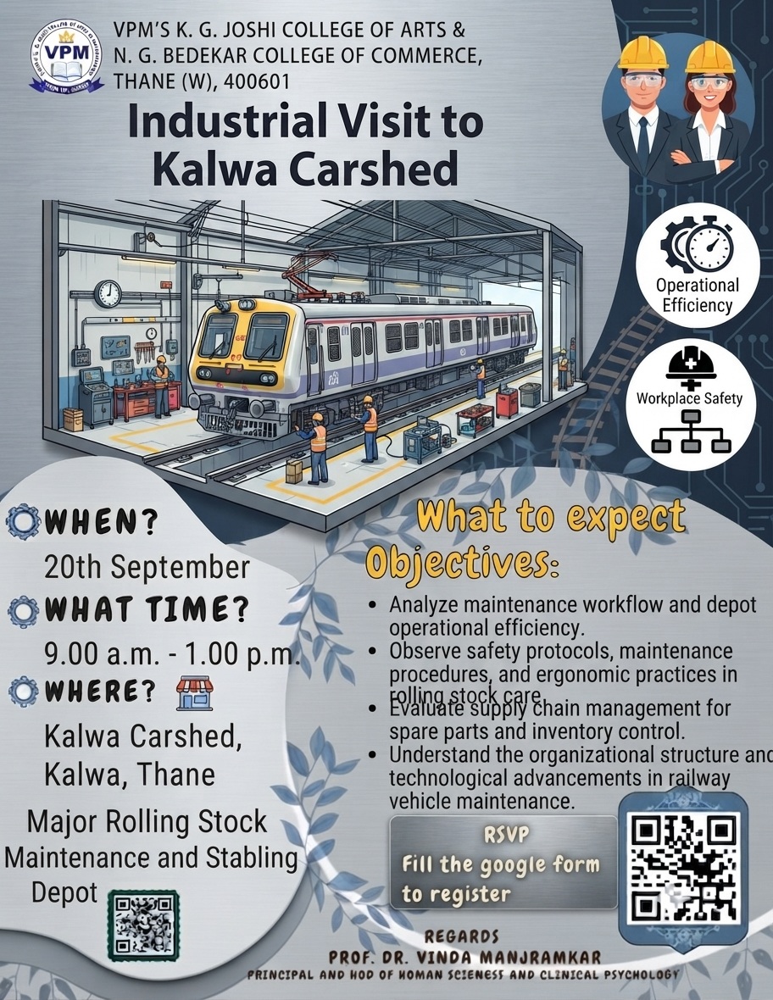
Attendance | 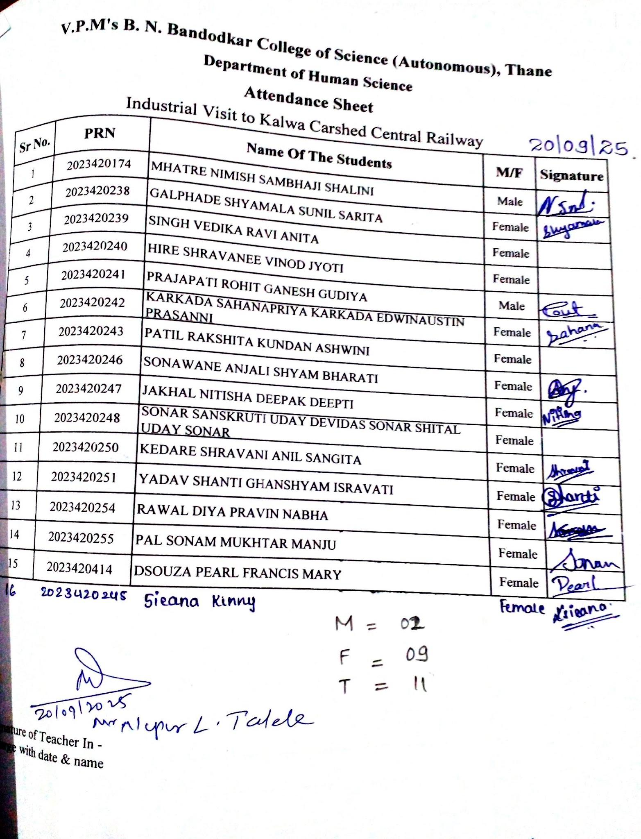
Feedback analysis | 

