TATA INSTITUTE OF SOCIAL SCIENCES
Title :  Date:  Time:  Venue:  Organized by:  Mode:  Details of Resource Person:  Objectives of the session:  Key Paricipants:  Key Takeaways:  Details of participants:  Additional Internal Support:  Name of the Teacher Incharge:  Summary: | Youth champion training- ICRMs multi-state implementation research study on mental well being among school and college students, conducted by TISS, Mumbai.  31st July 2025  11:30 AM  Msc Physics Lab  Department of Human Science and Department of Clinical Psychology.  Offline  - Aashna Sadana, Research Scientist, TISS  - Noyonika Gupta, Research Scientist,TISS  - To train selected students for “Youth Champions” who can lead mental health conversations in peer groups.  - To collect insights for ICRMs ongoing Multi-state research study on students mental well-being.  - To normalize talking about mental health in educational space.  - Students form Human Science Department.  - Students from Biotechnology Department.  - Students can be the change makers when it comes to peer mental health support.  - Youth Champions will play a crucial role in shaping future awareness campaigns on campus.  Total Participants :- 12  In-house students :- 10  Outsiders:-2  Nil  Dr. Jui Pujari  The TISS-ICMR session went beyond research, creating a safe and supportive space for students.

Two Geo-tagged Photo :

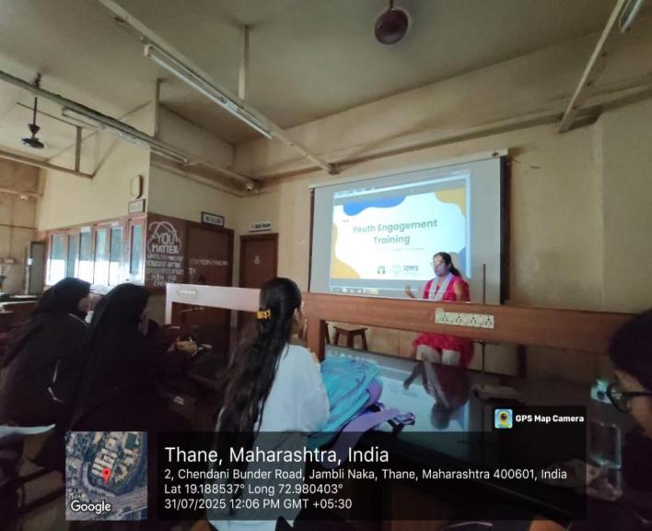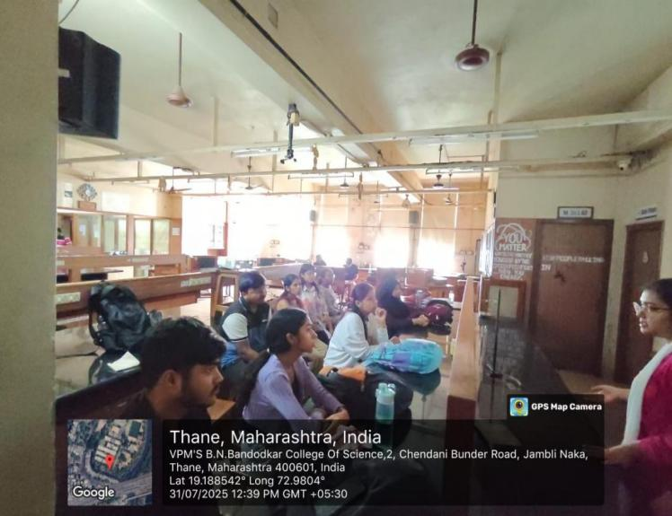

Flyer/ Notice:

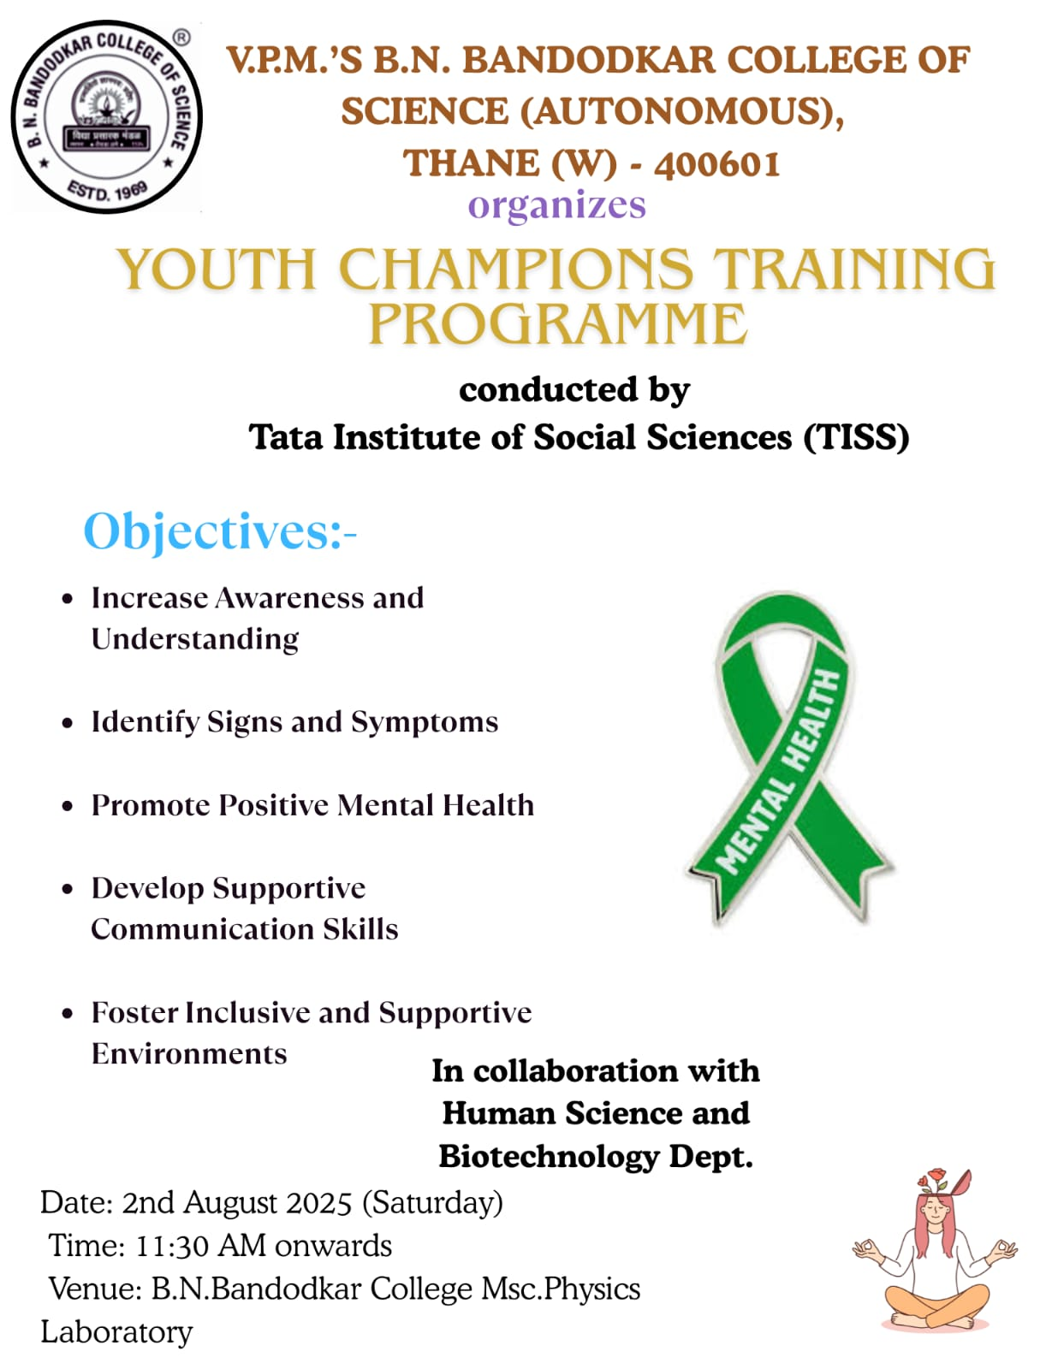

Attendence :

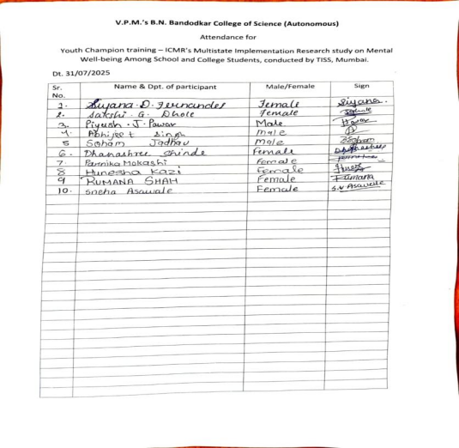

Graphical Representation of Feedback :

