VPM’s B.N Bandodkar College Of Science [Autonomous],Thane
Department of Human Science and Clinical Psychology
Name of activity:  Objective of the activity:  Collaborative institute:  Date:  Time:  Venue:  Mode:  Details of Resource Person:  Key Participants:  Key Takeaways:  Details of Participants :  Additional Information:  Name of Teacher in-charge: |  | Mental Health Awareness  - Objective is to reduce stigma surrounding mental illness.  - To promote early intervention and help-seeking behaviour.  - To improve overall well-being by increasing knowledge and understanding of mental health.  Department of Human Science and Department Biotechnology  14th August 2025  12:00 pm  Patanjali Auditorium  Offline  -  Students from Human science , Biotechnology, Clinical Psychology  - An Introduction to mental health awareness and to its committee in our college .  - Students to know that there is a safe and comfortable environment in our college specially for students suffering from peer mental health issues.  - Youth champions will play a crucial role in creating awareness through keeping events and lectures based on mental health .  Total Number : 81  Faculty Member: 2  students: 79  Nil  Dr. Jui Pujari
Two Geotagged Photos
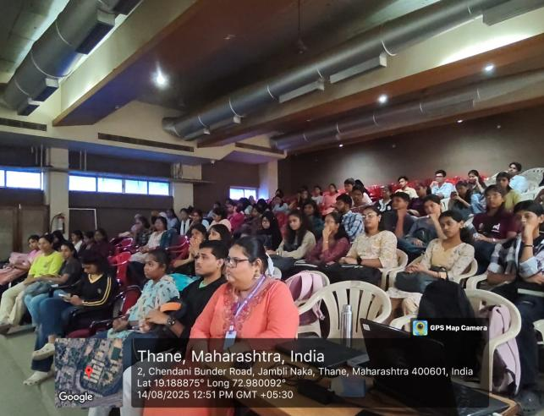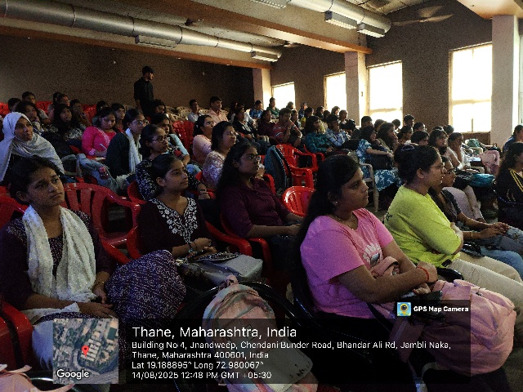

Flyer

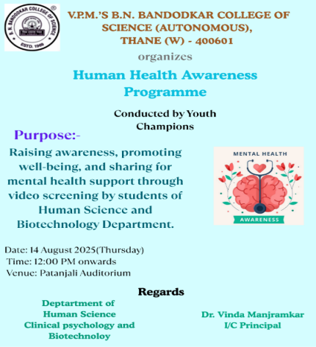
Attendance
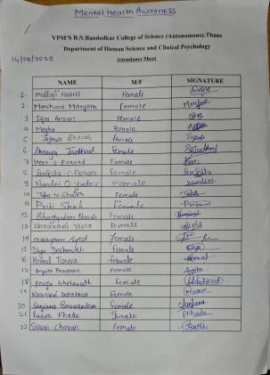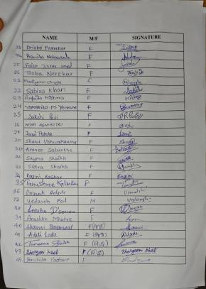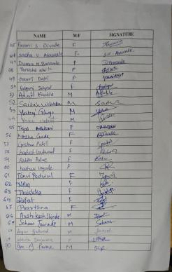

Graphical Representation of Feedback

