ACTIVITY REPORT

- NAME OF THE ACTIVITY  - OBJECTIVES OF THE ACTIVITY  - ORGANISING DEPARTMENT  - COLLABORATIVE INSTITUTE  - DATE (DD/MM/YYYY)  - VENUE  - MODE  - DETAILS OF THE RESOURCE PERSON  - KEY PARTICIPANTS  - REMARKABLE OUTCOMES/ KEY TAKE- AWAY MESSAGES  - DETAILS OF PARTICIPANTS –  - TOTAL NUMBER  - OUTSIDERS  - IN – HOUSE  - ADDITIONAL INFORMATION  - NAME OF THE COORDINATOR/ TEACHER IN CHARGE | JUVENILE OBSERVATION HOME VISIT  The main objectives of the visit are –  - To encourage students to gain exposure and understanding about the functioning of the Juvenile Observation Home.  - To know the key aspects of the Juvenile Justice Act and its implementation in the observation home  - To gain more understanding about the psychological perspective and the law.  Department Of Human Science  N/A  11/08/2025  Juvenile Observation Home, Umerkhadi, Sandhrust Road (W), Mumbai  Offline  Advocate Sachin Kate  Human Science & Clinical Psychology Students  - Students actively participated and asked their doubts and questions  - Enhanced the knowledge about the law of the juveniles and victims.  - An engaging atmosphere encouraged students to understand the ethical and moral practices.  15  NIL  FACULTY – 2 ; STUDENTS - 13  NIL  MS. Devangi Kale & Mr. Nupur

TWO GEO TAGGED PHOTOS
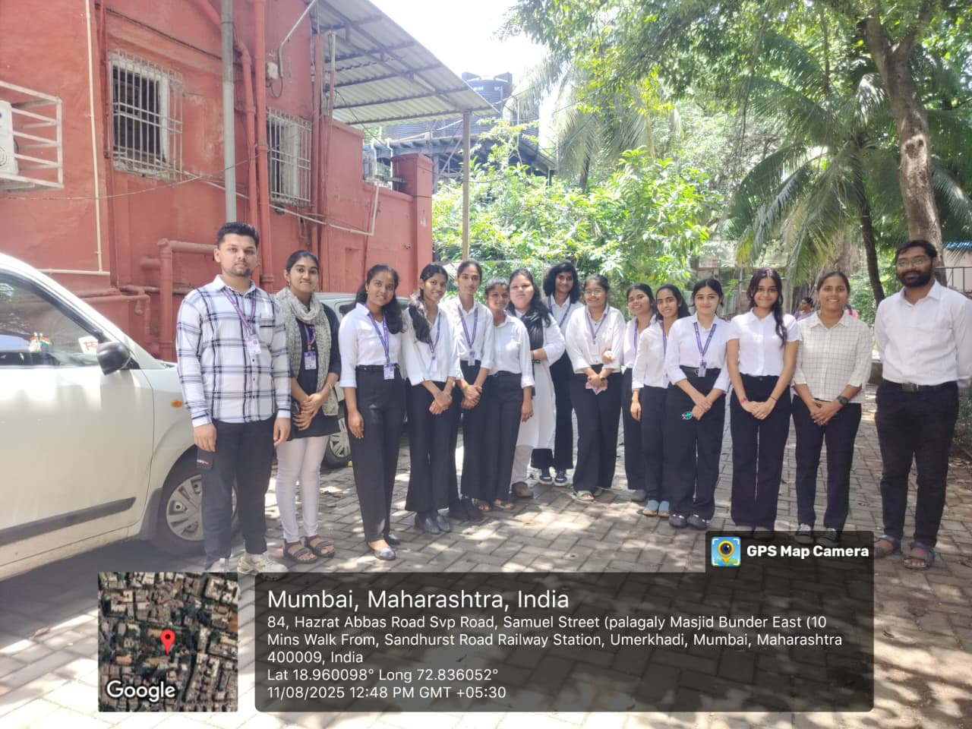
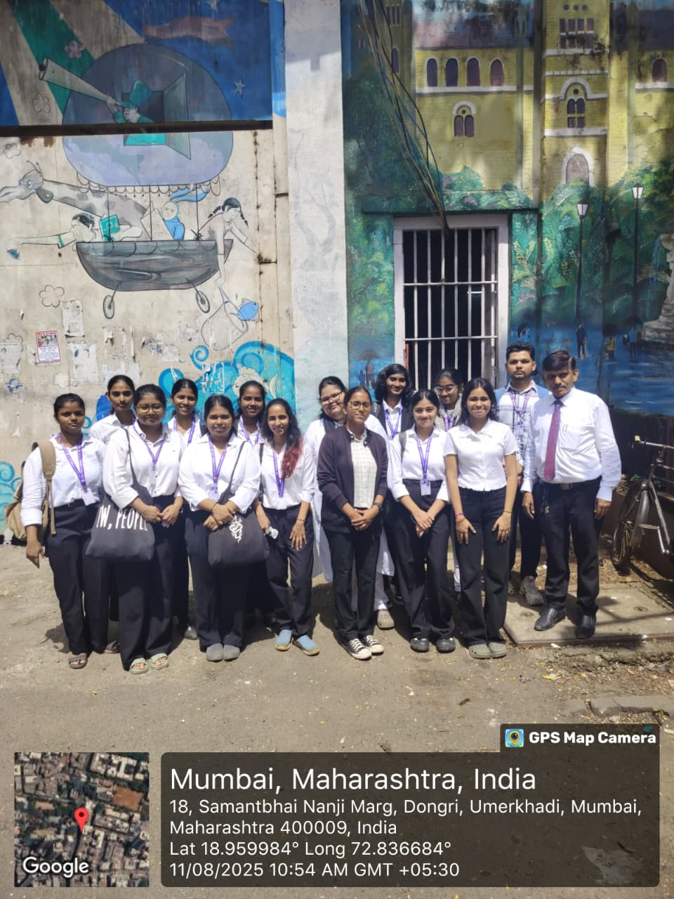

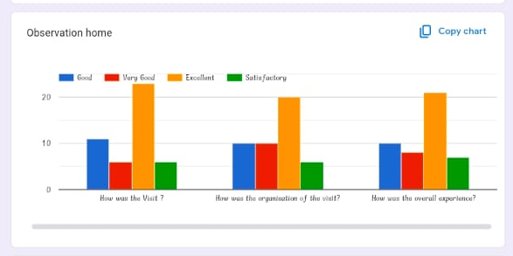
GRAPHICAL REPRESENTATION OF THE FEEDBACK
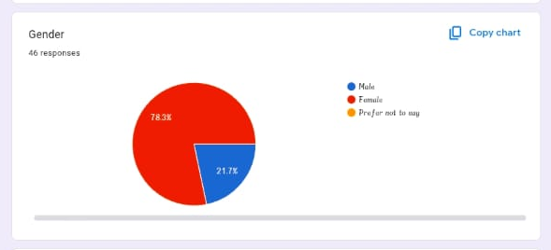

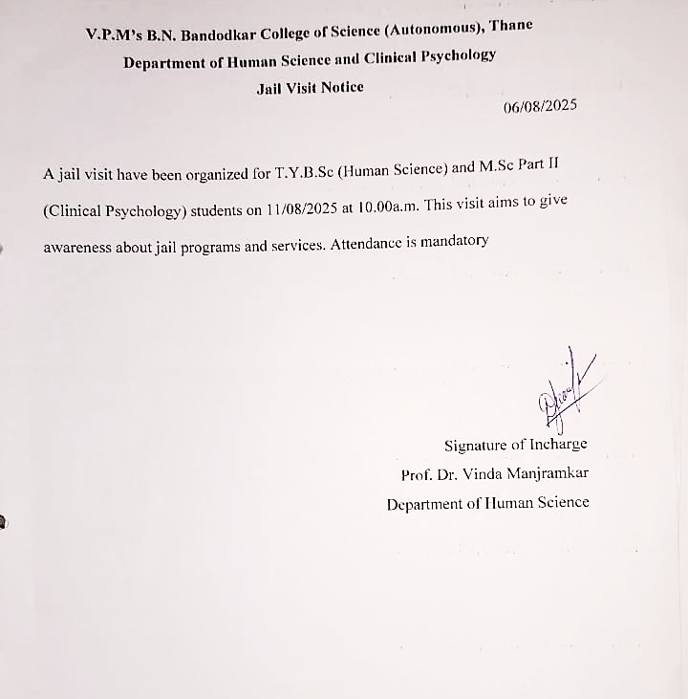
COLLEGE NOTICE

