Name of activity | Movie Screening
Objectives of the activity  (maximum 40 words) | - To inspire students by showing a real life example of resilience.  - To promote awareness about rights, capabilities and challenges and challenges of people with disabilities.
Organizing department/s | Human Science and NSS
Collaborative institute | NA
Date  ( DD / MM / YYYY ) | 10/08/2024  Saturday
Venue | Patanjali Auditorium, VPM’s B.N. Bandodkar college of science
Mode | Offline
Remarkable outcomes/ key take-away messages  (max. three) | - Taught students that disability does not define capability.  - Access to education and supportive mentors play a transformative role.  - Taught students that adaptability and innovation are crucial in everyone’s life.
Details of Teacher participants | Male | Female | Total
 | 00 | 01 | 01
Details of student participants | Male | Female | Total
 | 31 | 34 | 65
Total Number | 66
Outsiders | -
In-house | Total – 66  Faculty – 1 Students – 65
Additional information
Teacher InCharge | Ms Sayali Daptardar, Ms Priyanka Gaikwad

Flyer/Notice
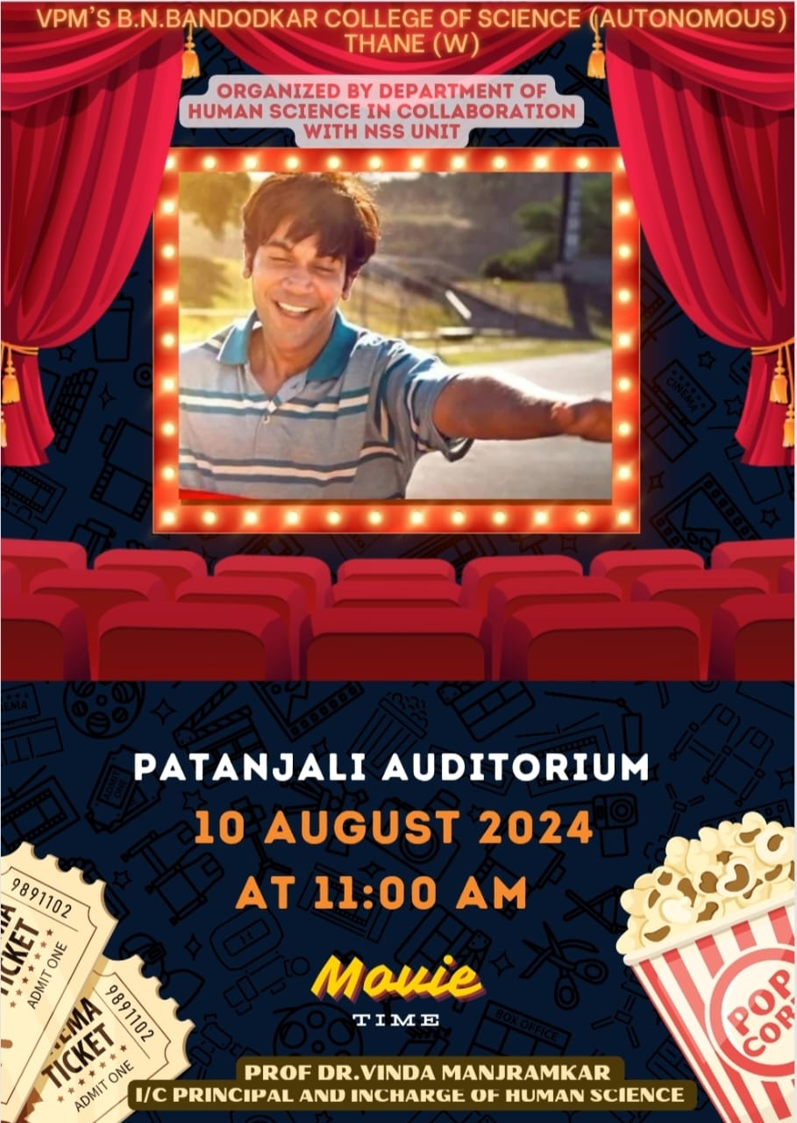

Attendance



