V.P.M’s B.N. Bandodkar College of Science (Autonomous)
Pune field visit by Department of Human Science /Clinical Psychology

Name of activity | Visit to Pune [For Study Tour]
Objectives of the activity  (maximum 40 words) | To gain insight into the rehabilitation processes and treatment methods for schizophrenia and addiction through campus tours and interactions with institutions, and to acquire knowledge about MPhil in Clinical Psychology and related courses, including degree information and professional requirements shared by RCI-licensed clinical psychologists and professors.
Organizing department. | Department of MSc Clinical Psychology.
Collaborative institute | Independent
Date  ( DD / MM / YYYY ) | 07/02/2025 To  08/02/2025
venue | - Schizophrenia Awareness Association [SAA]  - Maharashtra Institute Of Mental Health [MIMH].  - Muktangan – De-addiction Centre  - Raja Dinkar Kelkar Museum
Mode | Offline
Details of Resource person  (name, designation, institution) | - Sarika Chandak - RCI registered rehabilitation psychologist. [SAA]  - Shri. Ravindranath Chandran [Associate Volunteer [SAA]  - Mrs. Sayali Vaze – RCI Licensed Clinical Psychologist And Assistant Professor [MIMH]  - Mrs Deepika Patil – RCI Licensed Clinical Psychologist And Assistant Professor [MIMH]  - Mangesh Karlekar – Psychologist [Muktangan]
Key Participants | Psychology students of both part 1 and part 2
Remarkable outcomes/ key take-away messages  (max. three) | - Rehabilitation and Treatment : The Schizophrenia Awareness Association (SAA) and Muktangan De-addiction Centre emphasize a holistic approach to rehabilitation, incorporating counselling, medication, and engaging activities to facilitate recovery and relapse prevention.  - Academic and Professional Insights : The Maharashtra Institute of Mental Health (MIMH) campus tour and discussions with professors, including Assistant Professors Sayali Vaze and Deepika Patil, provided valuable information about MPhil in Clinical Psychology, admission procedures, and career prospects, highlighting the importance of collaborative efforts in addressing mental health concerns.  - Lifestyle, Challenges, and Holistic Wellbeing: Interacting with “Shubharties” (patients) at SAA and learning about Muktangan’s treatment approaches underscored the significance of a holistic approach to provide overall better wellbeing, promote risk reduction strategies, and address mental health concerns through comprehensive treatment plans that incorporate counselling, medication, and engaging activities
Details of participants | Total Number: 10  Teachers: 1 students: 9  Male: 3 female: 6

Principal: Dr. Vinda Manjramkar
Name of Coordinator: Dr. Vinda Manjramkar
Teachers in-charge for visit : Dr. Jui Pimple

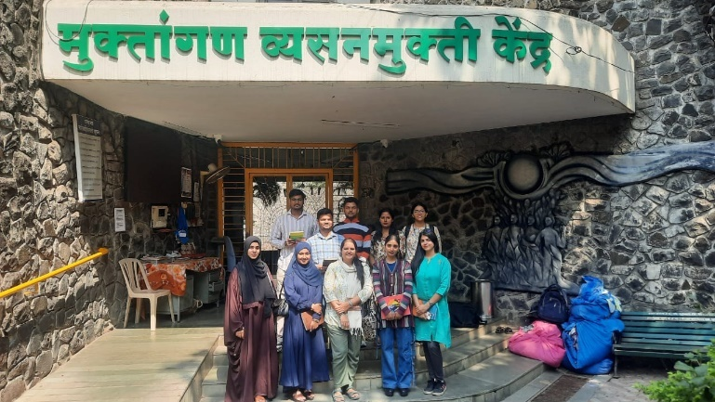

Geo tagged photos:

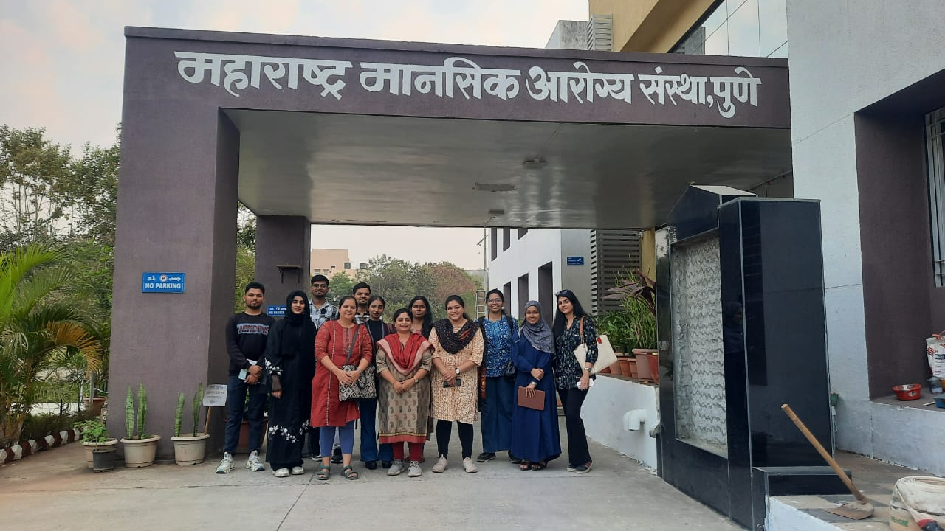
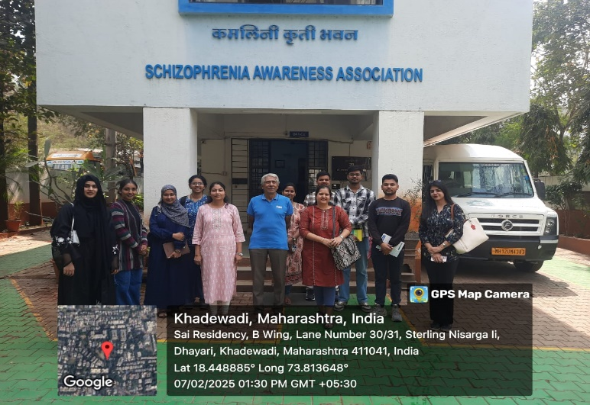

Graphical Representation of the Activity

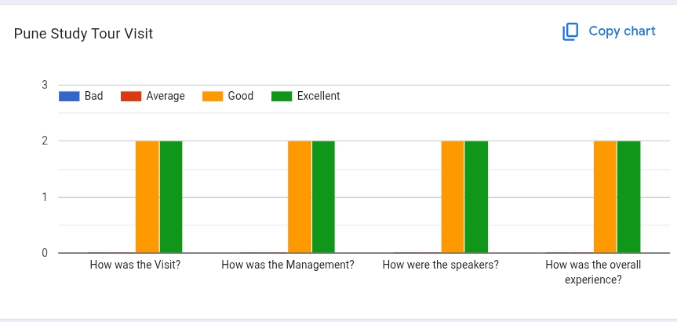

-x-

