|  |  |  |  |  |  |  |  |
| --- | --- | --- | --- | --- | --- | --- | --- |
| **Name of activity** | Career Guidance Session in Nutritional Sciences | | | | | | |
| **Objectives of the activity**  **(Maximum 40 words)** | 1. To give students career guidance in nutritional sciences 2. To make students aware about all aspects of nutritional sciences 3. Providing better foundation in mentioned field | | | | | | |
| **Organizing department/s** | Department of Human Sciences | | | | | | |
| **Collaborative institute** |  | | | | | | |
| **Date (DD / MM / YYYY)** | 18/07/2024 | | | | | | |
| **Venue** | VPM’s B.N. Bandodkar College of Science, (Autonomous) Thane. Patanjali Auditorium | | | | | | |
| **Mode** | Offline | | | | | | |
| **Details of Resource person**  **(Name, designation, institution)** | 1. Ms. Shravya Karkera 2. Ms. Vaishnavi Nakhwa | | | | | | |
| **Key Participants** | Degree students of B.N. Bandodkar college of science | | | | | | |
| **Remarkable outcomes/ key take-away messages**  (max. three) | 1. Students gained knowledge about nutritional sciences 2. Alumni’s helped students to be aware about the various fields 3. Students gained insight about the various opportunities in the field. | | | | | | |
| **Details of Teachers participants** | | | Male | Female | | Total | |
|  | | | 1 | 3 | | 4 | |
|  | | | | | | | |
| **Details of Student participants** | | Male | | | Female | | Total |
|  | | 22 | | | 64 | | 86 |
| Total Number | 90 | | | | | | |
| Outsiders | - | | | | | | |
| In-house | 90 | | | | | | |
|  |  | | | | | | |
| Additional information | Students later reported the positive feedback about the overall event. | | | | | | |
| **Name of Coordinator/ teacher in-charge** | Mr. Nupur L. Talele | | | | | | |

**Two Geo tagged photos:**

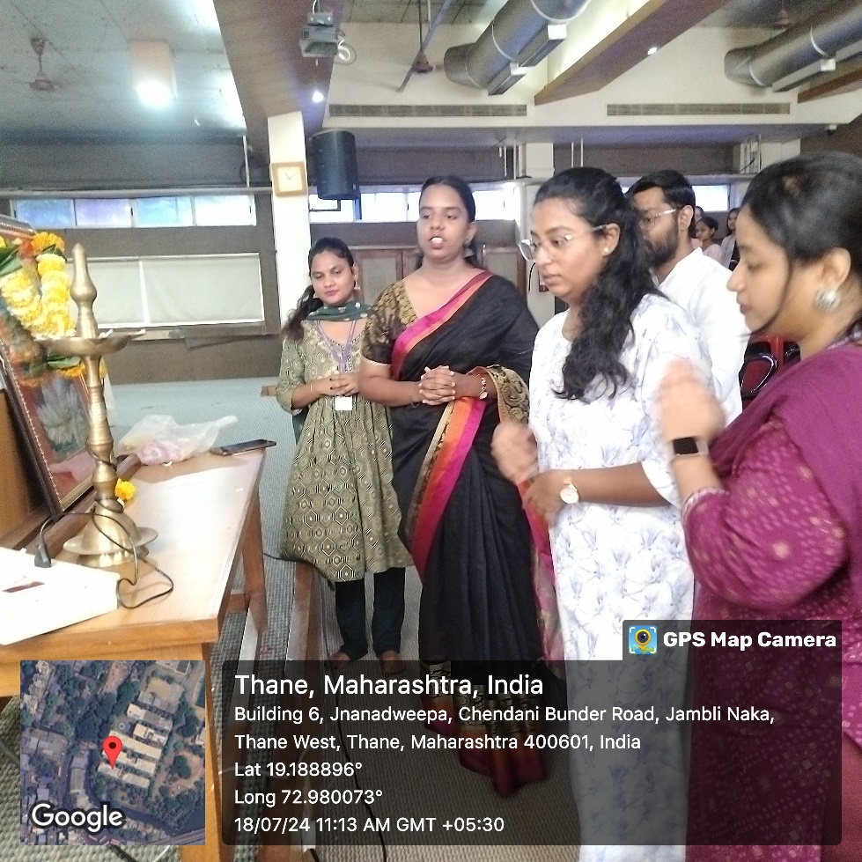

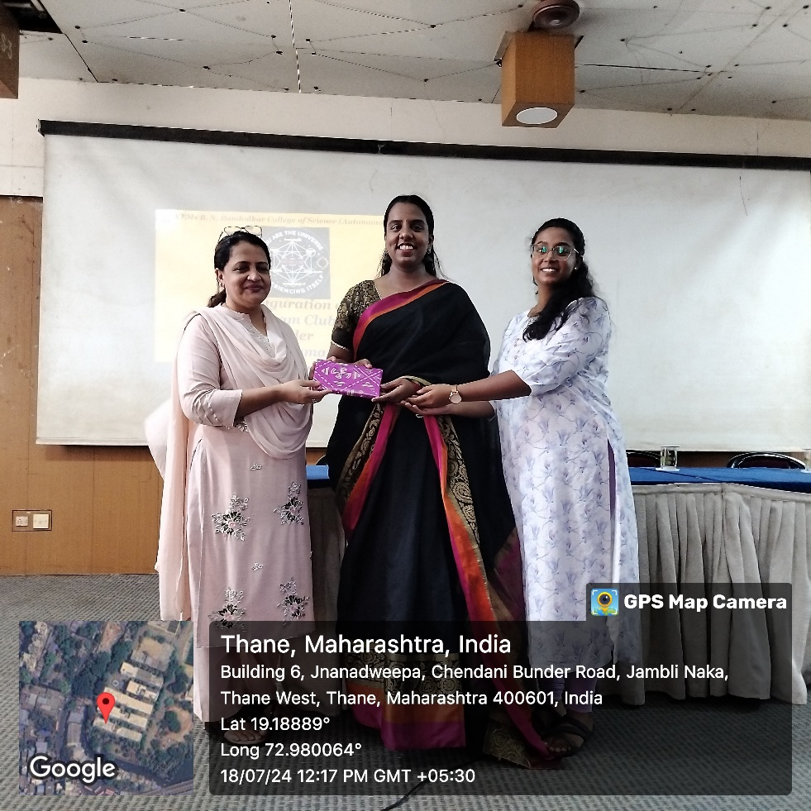

**Flyer/Notice**

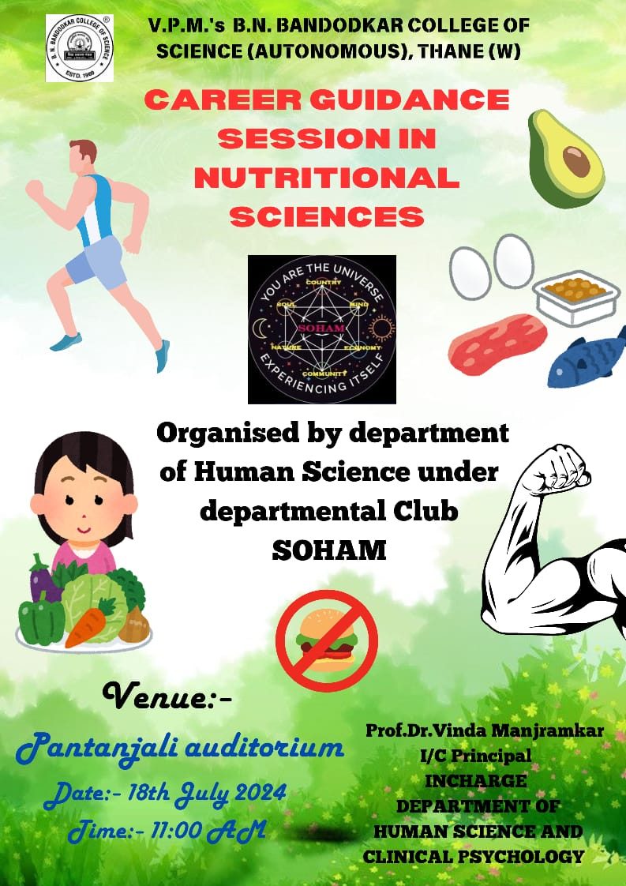

**Attendance**



