| **Name of activity** | **Mangroves Day Celebration.** | | |
| --- | --- | --- | --- |
| **Objectives of the activity**  **(maximum 40 words)** | 1. To highlight the role of mangroves in Biodiversity. 2. To educate students the importance and enhance students’ knowledge on the coastal areas. | | |
| **Organizing department/s** | Human Science and Zoology | | |
| **Collaborative institute** | NA | | |
| **Date**  **( DD / MM / YYYY )** | 26/07/2024  Friday | | |
| **Venue** | Zoology Lab | | |
| **Mode** | Offline | | |
| **Remarkable outcomes/ key take-away messages**  (max. three) | * It elaborated on the importance of Mangroves and how they provide habitats and breeding grounds for various marine species. * It boosted the information students had about their ecosystem. * Made students aware about important topics such as deforestation and conservation. | | |
| **Details of Teachers Participants** | Male | Female | Total |
|  | 01 | 03 | 04 |
| **Details of Student Participants** | Male | Female | Total |
|  | 17 | 42 | 59 |
| Total Number | 63 | | |
| Outsiders | - | | |
| In-house | Total – 63  Faculty – 4 Students – 59 | | |
| Additional information |  | | |
| Teacher InCharge | Ms Supriya Damle, Ms Priyanka Gaikwad | | |

**Flyer/Notice**

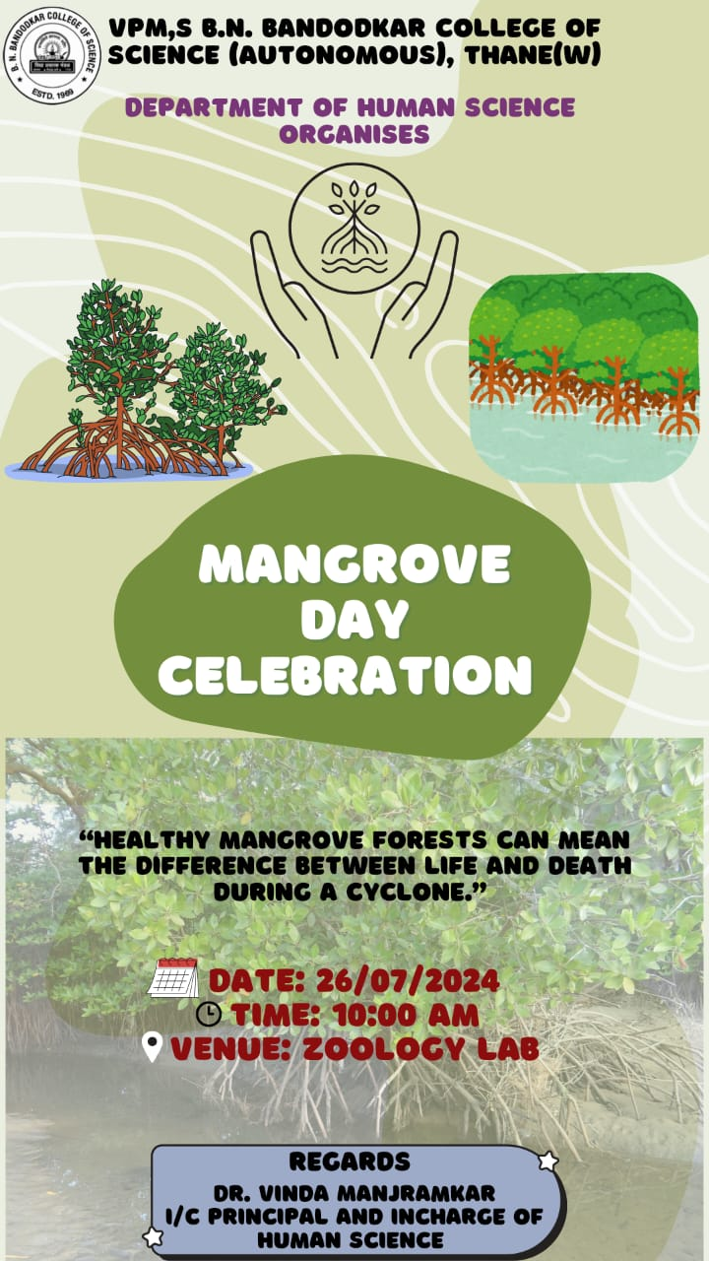

**Attendance**



